Week 1 – Python Essentials + AI Fundamentals

Day 1 – Python Setup and Basics

Install Python
Python can be downloaded by visiting the official site https://www.python.org/downloads/?utm_source=chatgpt.com
The version use is 3.15.0
Run the installer and if the installer offers add Python to PATH select it.
Open command prompt and execute the below command:
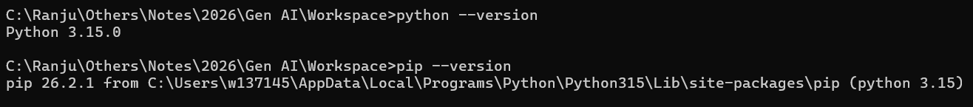

Create a project and virtual environment
A virtual environment keeps your project’s Python packages separate from other projects. This is particularly useful when you start working with GenAI libraries.
Run the below command in your terminal:

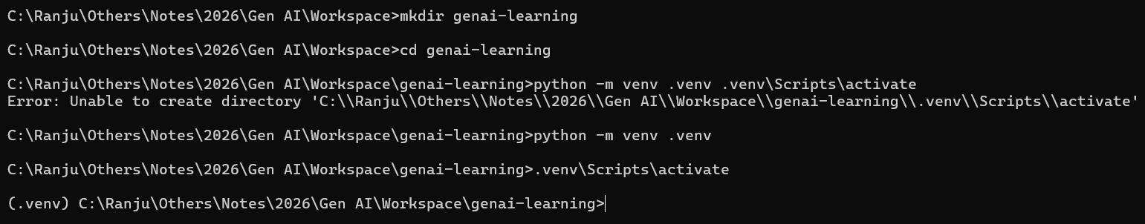

This will create a directory genai-learning. Within this folder will create a new folder .venv

Python Basics
- Variables and Data types
In Java, you declare a variable type. Python determines the variable type using the value.

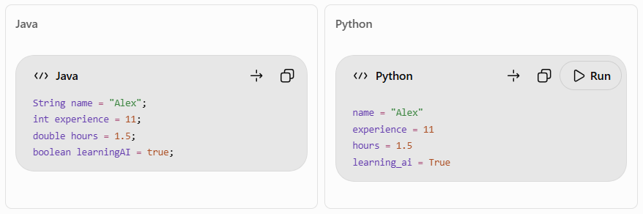

Type | Example
String (str) | “Java Developer”
Integer (int) | 11
Float (float) | 1.5
Boolean (bool) | True or False

Python is case-sensitive. True is correct but true is not.

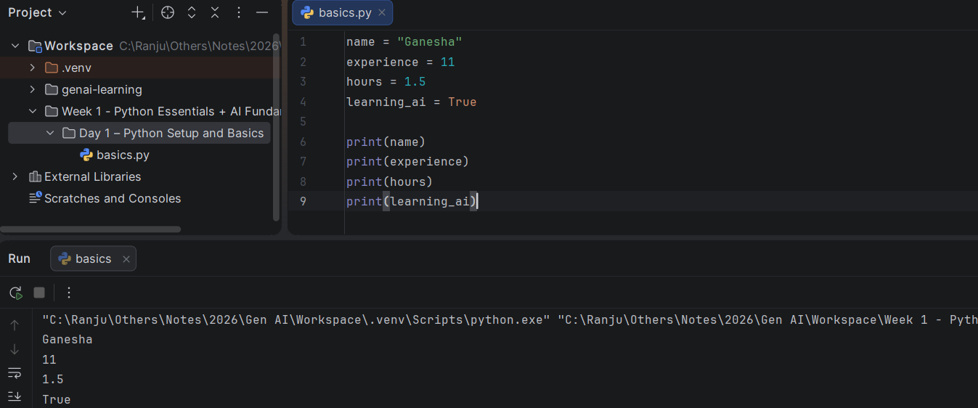

- String and formatted response
Python supports f-strings which allows to insert variables into the text.
It is equivalent to String.format() in Java.

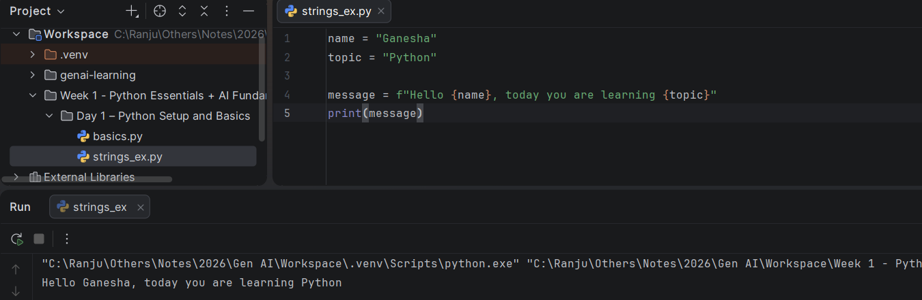

- Type Conversion
Python input() function returns string even if the user types the number.

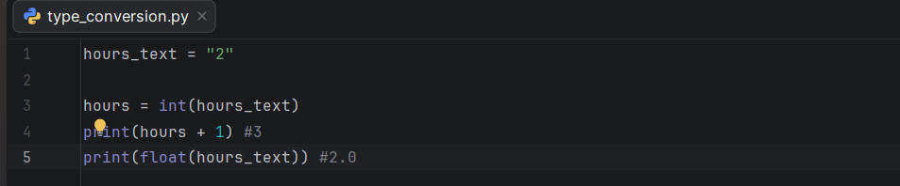

- Conditions
Python uses indentation to define code blocks instead of using curly brackets.

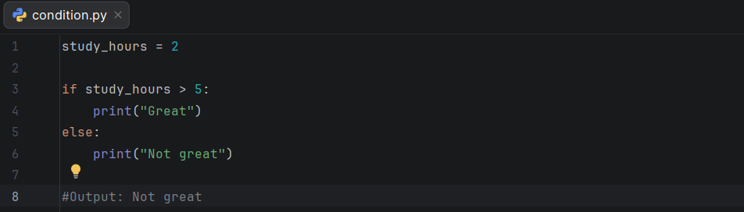

- Functions
Functions let you reuse logic without duplicating the code.

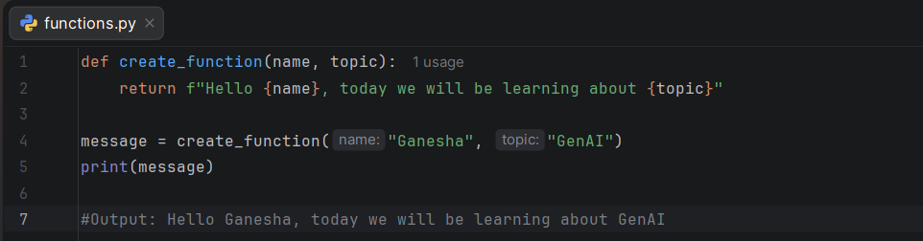
Day 1 Program:

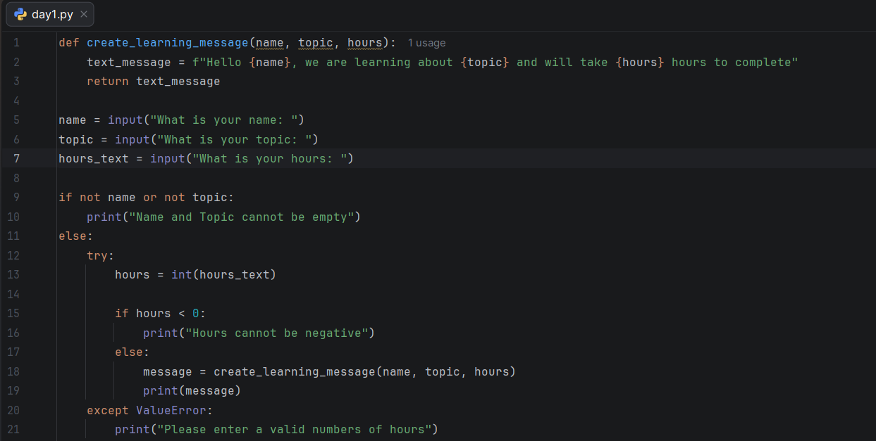

Output:
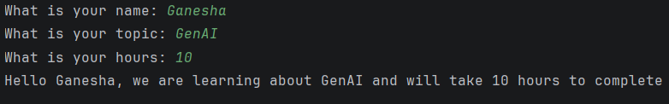

Assignment 1: Create variables for your name, years of Java experience, and whether you are learning GenAI. Print each value and its type.

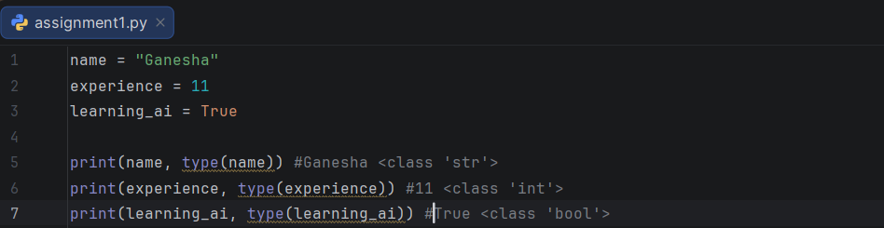

Assignment 2: Ask the user to enter two numbers, convert them to floats, and print their sum.

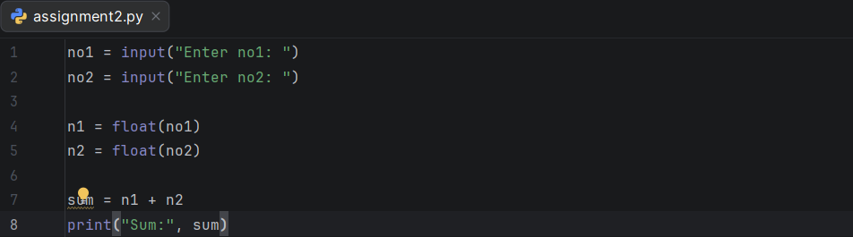

Assignment 3: Write a function that returns: “I have 11 years of Java experience and am learning GenAI.” Use a variable for the experience.

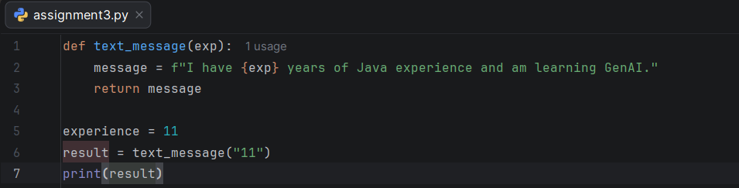
Assignment 4: Reject an empty name or topic in your learning-message program.

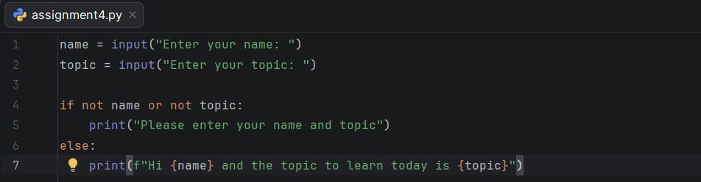

Assignment 5: Ask for a daily study target and calculate the total study hours for seven days.

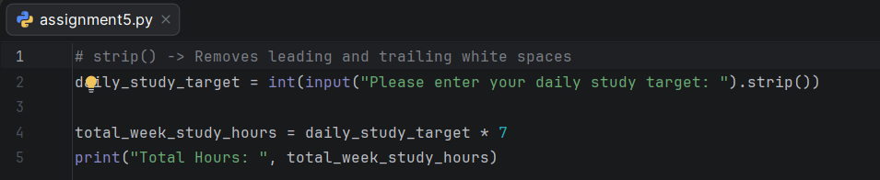

Note: While starting the IDE for the first time may get below error/warning:
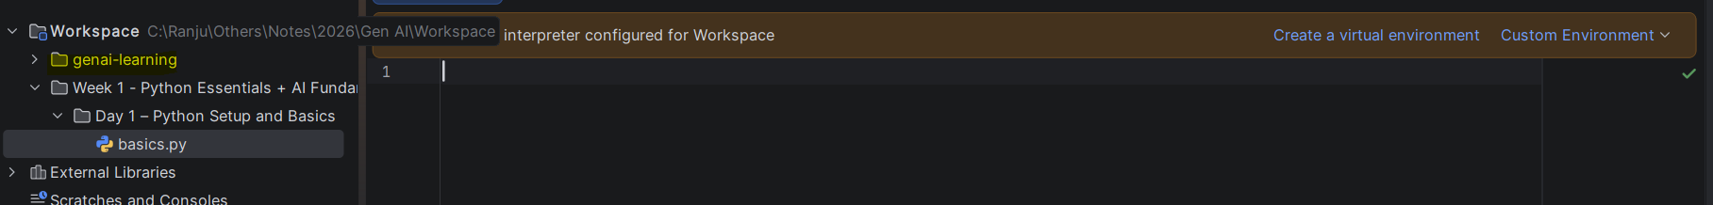
Message: No Python interpreter configured for Workspace
To resolve the above issue go to File -> Settings -> Python -> Interpreter -> Add Interpreter -> Add Local Interpreter and add the virtual environment path which was created earlier.

